The Solemn Liturgy of Good Friday

according to

The Book of Common Prayer 1979
Adapted for Rite I

10 April 2020 A.D.

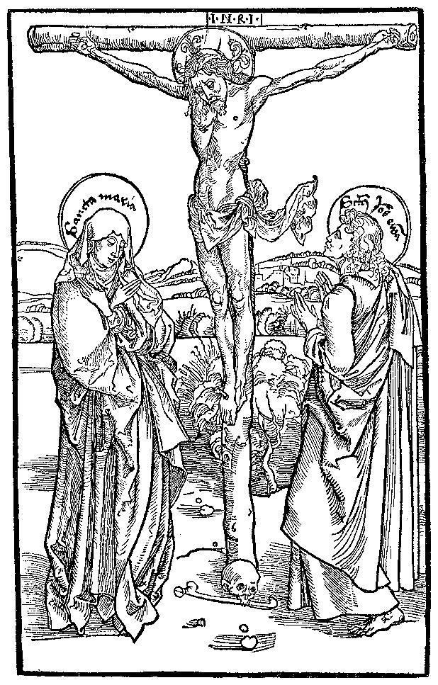

Nashotah House

Theological Seminary

Preparation Rites

On this day, the liturgy begins in silence.

All then kneel for silent prayer and the Priest lies prostrate before the Altar.

After a time, the Priest stands and begins the liturgy with the Collect of the Day.

Let us pray.

Almighty God, we beseech thee graciously to behold this thy family, for which our Lord Jesus Christ was contented to be betrayed, and given up into the hands of sinners, and to suffer death upon the cross; who now liveth and reigneth with thee and the Holy Ghost, one God, world without end. Amen.

All sit.

The Liturgy of the Word

First Lesson Isaiah 52:13—53:12

On this day, there is no announcement before the lesson, and nothing is said at its conclusion.

All stand to chant the Gradual Psalm.

Gradual Psalm Deus, Deus meus 22:1-11

All are seated for the Epistle.

Second Lesson Hebrews 10:1-25

On this day, there is no announcement before the Epistle, and nothing is said at its conclusion.

All stand for the Tract.

Tract Psalm 102:1-2
Lord, hear my prayer, and let my cry come be-fore you; *
hide not your face from me in the day of my trouble.
Incline your ear to me; *
when I call, make haste to an-swer me,

All are then seated for the Passion Gospel.

Passion Gospel John 19:1-37

The Passion Gospel is announced in the following manner
The Passion of our Lord Jesus Christ according to John.

The customary responses before and after the Gospel are omitted.
At the verse which mentions the arrival at Golgotha (John 19:17) all stand.

At the verse which announces the death of Jesus (John 19:30), all kneel for a time in silence.

When the Ministers stand, the People also stand, and remain standing through the conclusion of the Passion Gospel, after which all sing the Hymn and sit for the Sermon.

Sermon
The Rev’d Matthew S. C. Olver, Ph.D.
Assistant Professor of Liturgics

Hymn 166 (verse 1-2) Pange lingua

The Solemn Collects

All standing, the Priest turns to the people and says,
Dear People of God: Our heavenly Father sent his Son into the world, not to condemn the world, but that the world through him might be saved; that all who believe in him might be delivered from the power of sin and death, and become heirs with him of everlasting life.

We pray, therefore, for people everywhere according to their needs.

The Priest then turns to the Altar for the Solemn Collects.

I.
Let us pray for the holy Catholic Church of Christ throughout the world;
For its unity in witness and service;
For all bishops and other ministers and the people whom they serve;
For Justin, Archbishop of Canterbury and all Primates of the Anglican Communion; for Steven, Bishop of Milwaukee, and for our own bishops;
For this House, and for Garwood and Labin, its authorities;
For all Christians in this community;
For those about to be baptized (particularly___________);
That God will confirm his Church in faith, increase it in love, and preserve it in peace.

Priest Let us kneel in silent prayer.

The People kneel and pray in silence.

Priest Arise.

Almighty and everlasting God, by whose Spirit the whole body of thy faithful people is governed and sanctified: Receive our supplications and prayers which we offer before thee for all members of thy holy Church, that in their vocation and ministry they may truly and godly serve thee; through our Lord and Savior Jesus Christ. Amen.

II.
Let us pray for all nations and peoples of the earth, and for those in authority among them;
For N., the President of the United States;
For the legislature and for the courts of justice;
For all who are in any authority and for all who serve the common good;
That by God's help they may seek justice and truth, and live in peace and concord; remembering the account they shall be called to give at the last great day;

Priest Let us kneel in silent prayer.

The People kneel and pray in silence.

Priest Arise.

O Almighty God, kindle, we beseech thee, in every heart the true love of peace, and guide with thy wisdom those who take counsel for the nations of the earth, that in tranquility thy dominion may increase till the earth is filled with the knowledge of thy love; through Jesus Christ our Lord. Amen.

III.
Let us pray for all who suffer and are afflicted in body or in mind;
For the hungry and the homeless, the destitute and the oppressed;
For the sick, the wounded, and the crippled;
For those in loneliness, fear, and anguish;
For those who face temptation, doubt, and despair;
For the sorrowful and bereaved;
For prisoners and captives, and those in mortal danger;
That God in his mercy will comfort and relieve them, and grant them the knowledge of his love, and stir up in us the will and patience to minister to their needs.

Priest Let us kneel in silent prayer.

The People kneel and pray in silence.

Priest Arise.

Almighty and most gracious God, who dost comfort all who sorrow and strengthen all who suffer: Let the cry of those in misery and need come before thee, that they may find thy mercy present with them in all their afflictions; and give us, we beseech thee, the strength to serve them for the sake of him who suffered for us, even Jesus Christ, thy Son our Lord. Amen.

IV.
Let us pray to God, who alone makest us to dwell in safety, for people of every language, people, and nation who are afflicted by this virus:
For those who are ill, in isolation, or anxiety;
For those who take council for the nations of the earth and for the common good;
For those who are weighed down with depression and all who suffer from mental illness;
For the isolated and housebound, the lonely and the despondent:
For doctors, nurses and all who care for the sick and dying;
For the vulnerable and the fearful, for the gravely ill and the dying;
For all who suffer and know not the Lord Jesus, and who have none to pray for them.
That God, in his mercy, will look upon the whole human race with compassion and love.

Priest Let us kneel in silent prayer.

The People kneel and pray in silence.

Priest Arise.

O Almighty God, who seest that we have no power of ourselves to help ourselves, in this time of grievous sickness, we flee unto Thee for succour: Keep us both outwardly in our bodies and inwardly in our souls, that we may be defended from all adversities which may happen to the body, and from all evil thoughts which may assault and hurt the soul; and grant that, perceiving how frail and uncertain our life is, we may apply our hearts unto that heavenly wisdom which leadeth to eternal life; through Jesus Christ our Lord. Amen.

V.
Let us pray for all who have not received the Gospel of Christ;
For those who have never heard the word of salvation;
For those who have lost their faith;
For those hardened by sin or indifference;
For the contemptuous and the scornful;
For those who are enemies of the cross of Christ and persecutors of his disciples;
For those who in the name of Christ have persecuted others;
That God will open their hearts to the truth, and lead them to faith and obedience.

Priest Let us kneel in silent prayer.

The People kneel and pray in silence.

Priest Arise.

O most merciful God, who hast made all men, and hatest nothing that thou hast made, nor desirest the death of a sinner, but rather that he should be converted and live; Have mercy upon all who know thee not as thou art revealed in the Gospel of thy Son. Take from them all ignorance, hardness of heart, and contempt of thy Word; and so fetch them home, blessed Lord, to thy fold, that they may be made one flock under one shepherd, Jesus Christ our Lord. Amen.

VI.
Let us commit ourselves to God, and pray for the grace of a holy life, that, with all who have departed this world and have died in the peace of Christ, and those whose faith is
known to God alone, we may be accounted worthy to enter into the fullness of the joy of our Lord, and receive the crown of life in the day of resurrection.

Priest Let us kneel in silent prayer.

The People kneel and pray in silence.

Priest Arise.

O God of unchangeable power and eternal light: Look favorably upon thy whole Church, that wonderful and sacred mystery; by the tranquil operation of thy perpetual providence, carry out the work of salvation; let the whole world see and know that things which were cast down are being raised up, and things which had grown old are being made new, and that all things are being brought to their perfection by him through whom all things were made, thy Son Jesus Christ our Lord; who liveth and reigneth with thee, in the unity of the Holy Spirit, one God, for ever and ever. Amen.
The Veneration of the Cross

Hymn 166 (verse 3-4) Pange lingua

A large wooden cross with an image of the Crucified is presented to the people.

The bearer of the Cross pauses three times; at each pause, the Cross is progressively uncovered and is lifted for all to see. Each time, the cantor will sing the following, the People responding.

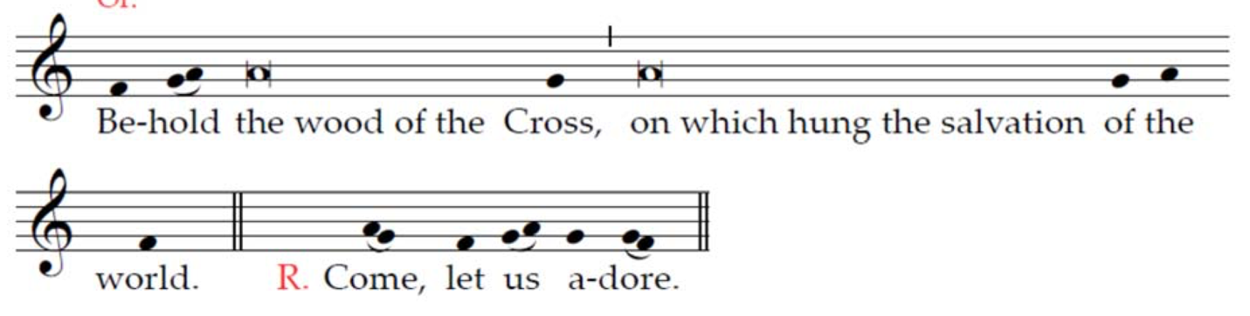

Hymn 166 (verse 5-6) Pange lingua

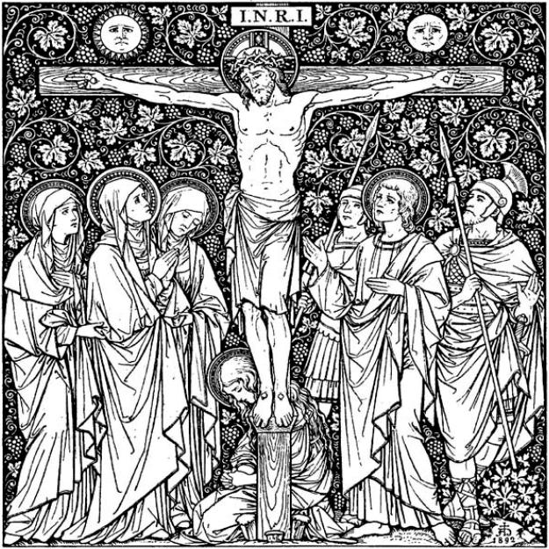
Concluding Rites

The Lord’s Prayer

And now as our Savior Christ hath taught us, we are bold to say:

After a time, the Celebrant alone stands, and chants the following prayer.
Lord Jesus Christ, Son of the living God, we pray thee to set thy passion, cross, and death between thy judgment and our souls, now and in the hour of our death. Give mercy and grace to the living; pardon and rest to the dead; to thy holy Church peace and concord; and to us sinners everlasting life and glory; for with the Father and the Holy Spirit thou livest and reignest, one God, now and for ever.
All Amen.

No blessing or dismissal is added.

