The Daily Office
and
The Holy Eucharist

according to

The Book of Common Prayer 1979 – Rite I
in the time of the Pandemic
for
Eastertide

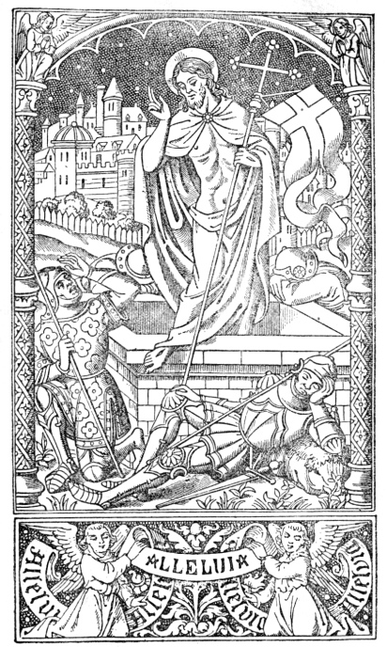

Nashotah House
Theological Seminary
Regina Caeli

Said from Easter Day through Matins of the Eve of Trinity Sunday

The Regina Caeli traditionally replaces the Angelus during Eastertide.

At Nashotah House, it is normally rung at 7:45 AM, before each morning and evening Office, and, when classes are in session, at 12:30 pm before lunch, to conclude the second class session.

Whether or not one prays this text, all students are to stand respectfully and engage in silent prayer, whether this text or another.

The bell tolls twice for each line of the antiphon; then the versicle and response is said;
Then the bell then tolls 8 times (16, because the bell tolls twice with each pull)
as the collect is said.

[ring 2x] X O Queen of heaven, be joyful, alleluia;
[ring 2x] Because he whom so meetly thou barest, alleluia,
[ring 2x] Hath arisen, as he promised, alleluia:
[ring 2x] Pray for us to the Father, alleluia.

V. Rejoice and be glad, O virgin Mary, alleluia.
R. For the Lord is risen indeed, alleluia.

Let us pray.
[ring 8x]
O GOD, who, by the resurrection of thy Son, Jesus Christ, didst vouchsafe to give gladness unto the world: Grant, we beseech thee, that we, being holpen by the Virgin Mary, his Mother, may attain unto the joys of everlasting life. Through the same Christ our Lord. Amen.

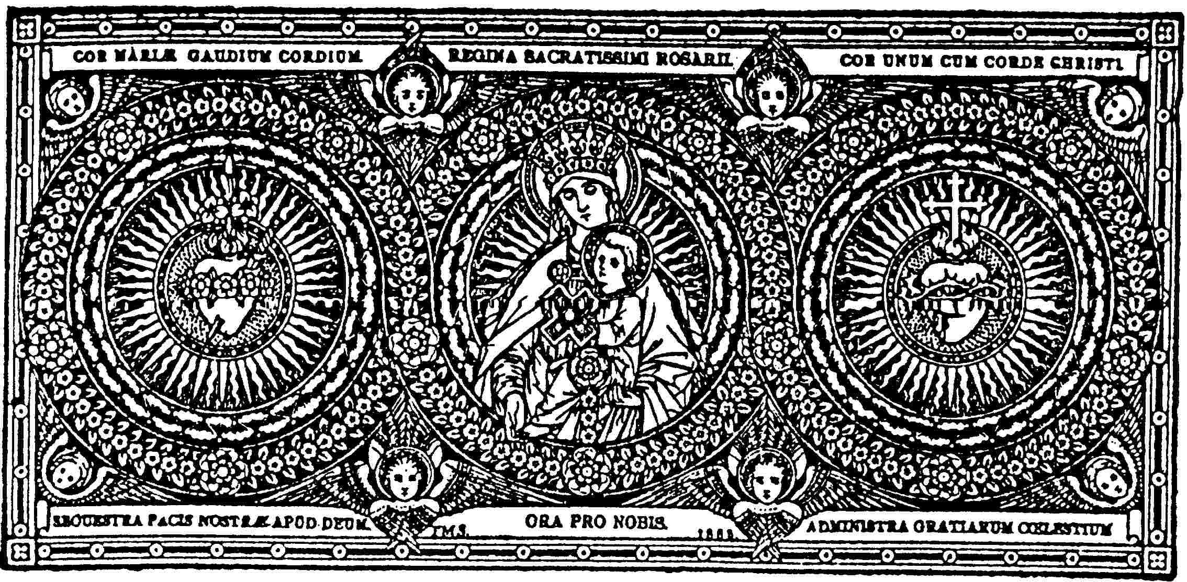

Table of Contents
Regina Caeli 1
Morning Prayer & Holy Communion 3
Evening Prayer 18
Spiritual Communion 22
The Prayer for Nashotah House 26

Morning Prayer & Holy Communion

Mon—Sat, 7:45 AM
Sundays, 9:30 AM

- indicates when the Sign of the Cross is commonly made

Morning Prayer
The Regina Caeli is rung;
All rise and pray together in silence. See inside front cover for the text and instructions.

The Invitatory and Psalter BCP, p. 42

The Officiant begins the service one of the following sentences of Scripture.

Thanks be to God, which giveth us the victory through our Lord Jesus Christ.
1 Corinthians 15:57

If ye then be risen with Christ, seek the things which are above, where Christ sitteth on the right hand of God. Colossians 3:1

O Lord, open thou our lips.
And our mouth shall show forth thy praise.

(bow) Glory to the Father, and to the Son,
and to the Holy Spirit: (rise)
as it was in the beginning, is now,
and will be for ever. Amen.

Alleluia!

Christ our Passover Pascha Nostrum BCP, p. 46
1 Corinthians 5:7 8; Romans 6:9 11; 1 Corinthians 15:20 22

Alleluia.
Christ our Passover is sacrificed for us; *
therefore let us keep the feast,
Not with old leaven,
neither with the leaven of malice and wickedness, *
but with the unleavened bread of sincerity and truth. Alleluia.

Christ being raised from the dead dieth no more; *
death hath no more dominion over him.
For in that he died, he died unto sin once; *
but in that he liveth, he liveth unto God.
Likewise reckon ye also yourselves to be dead indeed unto sin,*
but alive unto God through Jesus Christ our Lord. Alleluia.

Christ is risen from the dead, *
and become the first fruits of them that slept.
For since by man came death, *
by man came also the resurrection of the dead.
For as in Adam all die, *
even so in Christ shall all be made alive. Alleluia.

The Psalter (seated)

The Cantor says the first line of the first verse, and the congregation responds with the second half of the verse. From this point, the Gospel or Cantoris side prays the even numbered verses, and the Epistle or Decani side prays the odd numbered verses. A distinct pause, long enough to say the Name of Jesus, is observed at the asterisk halfway through each Psalm.

The Gloria Patri is said in unison only once, at the end of all appointed Psalm.
(bow) Glory to the Father, and to the Son,
and to the Holy Spirit: (rise)
as it was in the beginning, is now,
and will be for ever. Amen.

The Lesson (seated)

When the Officiant stands, all stand and join in the appointed Canticle.

The Canticle (standing)

All Major Feasts Te Deum BCP, p. 52
Monday Surge, illuminare 87
Tuesday Benedictus es, Domine 49
Wednesday Benedictus Dominus Deus 50
Thursday Te Deum 52
Friday Cantemus Domino 83
Saturday Benedicite omina opera 47

The Apostles’ Creed (standing) BCP, p. 53

I believe in God, the Father almighty,
maker of heaven and earth.
And in Jesus Christ, his only Son, our Lord.
who was conceived by the Holy Ghost,
born of the Virgin Mary.
suffered under Pontius Pilate,
was crucified, dead, and buried.
He descended into hell.
The third day he rose again from the dead.
He ascended into heaven,
and sitteth on the right hand of God the Father almighty.
From thence he shall come to judge the quick and the dead.
I believe in the Holy Ghost,
the holy catholic Church,
the communion of saints,
the forgiveness of sins,
the resurrection of the body,
and the life everlasting.
Amen.

The Prayers BCP, p. 54

The Lord be with you.
And with thy spirit.
Let us pray.

Suffrages B BCP, p. 55

℣. O Lord, save thy people, and bless thine heritage;
℟. Govern them and lift them up for ever.

℣. Day by day we magnify thee;
℟. And we worship thy Name ever, world without end.

℣. Vouchsafe, O Lord, to keep us this day without sin;
℟. O Lord, have mercy upon us, have mercy upon us.

℣. O Lord, let thy mercy be upon us;
℟. As our trust is in thee.

℣. O Lord, in thee have I trusted;
℟. Let me never be confounded.

The Officiant then prays the appointed collects; at the end of each, the People say, Amen.

℣. Let us bless the Lord. Alleluia, alleluia. BCP, p. 59
℟. Thanks be to God. Alleluia, alleluia.

The Officiant then concludes with a sentence from Scripture, and the People make the Sign of the Cross.

All sit until the Celebrant stands to go to the altar and remain so through the Collect of the Day.

The Supplication (see the following page) is often being said between the Office and the Mass during this period of time.

The Supplication

The Supplication, especially appropriate in times of danger and anxiety, might be added here.

O Lord, arise, help us;
And deliver us for thy Name’s sake.

O God, we have heard with our ears, and our fathers have declared unto us, the noble works that thou didst in their days, and in the old time before them.

O Lord, arise, help us;
and deliver us for thy Name’s sake.

Glory be to the Father, and to the Son, and to the Holy Ghost; as it was in the beginning, is now, and ever shall be, world without end. Amen.

O Lord, arise, help us;
and deliver us for thy Name’s sake.

V. From our enemies defend us, O Christ;
R. Graciously behold our afflictions.
V. With pity behold the sorrows of our hearts;
R. Mercifully forgive the sins of thy people.

V. Favorably with mercy hear our prayers;
R. O Son of David, have mercy upon us.
V. Both now and ever vouchsafe to hear us, O Christ;
R. Graciously hear us, O Christ; graciously hear us, O Lord Christ.

V. O Lord, let thy mercy be upon us;
R. As we put our trust in thee.

The Officiant concludes
Let us pray.
We humbly beseech thee, O Father, mercifully to look upon our infirmities; and, for the glory of thy Name, turn from us all those evils that we most justly have deserved; and grant that in all our troubles we may put our whole trust and confidence in thy mercy, and evermore serve thee in holiness and pureness of living, to thy honor and glory; through our only Mediator and Advocate, Jesus Christ our Lord. Amen.

The Holy Eucharist

The Entrance Rites

Opening Acclamation BCP, p. 318

Collect for Purity

The Celebrant continues
Almighty God, unto whom all hearts are open, all desires known, and from whom no secrets are hid: Cleanse the thoughts of our hearts by the inspiration of thy Holy Spirit, that we may perfectly love thee, and worthily magnify thy holy Name; through Christ our Lord. Amen.

Kyrie eleison or Trisagion

Gloria in excelsis Deo
On Sundays, during the Octave of Easter, and on Major Feasts, the Gloria in excelsis is added.

Glory be to God on high,
and on earth peace, good will towards men.

We praise thee, we bless thee,
(bow) we worship thee, (rise)
we glorify thee,
we give thanks to thee for thy great glory,
O Lord God, heavenly King, God the Father Almighty.

O Lord, the only-begotten Son, Jesus Christ;
O Lord God, Lamb of God, Son of the Father,
that takest away the sins of the world,
have mercy upon us.

Thou that takes away the sins of the world,
(bow) receive our prayer. (rise)
Thou that sittest at the right hand of God the Father,
have mercy upon us.

For thou only art holy;
thou only art the Lord;
thou only, O Christ,
with the Holy Ghost,
art most high in the glory of God the Father.
X Amen.

The Collect of the Day BCP, p. 357

The Celebrant prays the collect of the day, to which the People respond
Amen.

All sit for the lessons.

The Liturgy of the Word

First Lesson

At the conclusion of the lesson, the Reader says
The Word of the Lord.
Thanks be to God.

All stand.

Second Lesson (on Sundays and Major Feasts)
Gradual (on Sundays and Major Feasts)

Alleluia (may be sung or said by the Celebrant)

Gospel

The ✠ ✠ ✠ Holy Gospel of our Lord Jesus Christ, according to ___.
Glory be to thee, O Lord.

After the Gospel, the Deacon says
The Gospel of the Lord.
Praise to thee, O Christ.

Homily (seated)

Nicene Creed (on Sundays and Major Feasts) BCP, p. 327

I believe in one God,
the Father Almighty,
maker of heaven and earth,
and of all things visible and invisible;

And in one Lord Jesus Christ,
the only-begotten Son of God,
begotten of his Father before all worlds,
God of God, Light of Light,
very God of very God,
begotten, not made,
being of one substance with the Father;
by whom all things were made;
who for us men and for our salvation
came down from heaven,
(bow) and was incarnate by the Holy Ghost of the Virgin Mary,
and was made man; (rise)
and was crucified also for us under Pontius Pilate;
he suffered and was buried;
and the third day he rose again according to the Scriptures,
and ascended into heaven,
and sitteth on the right hand of the Father;
and he shall come again, with glory,
to judge both the quick and the dead;
whose kingdom shall have no end.

And I believe in the Holy Ghost the Lord, and Giver of Life,
who proceedeth from the Father and the Son;
who with the Father and the Son together is worshiped and glorified;
who spake by the Prophets.
And I believe one holy Catholic and Apostolic Church;
I acknowledge one Baptism for the remission of sins;
and I look for the resurrection of the dead,
and the life of the world to come. Amen.

The Prayer for the Whole State of Christ’s Church (standing) BCP, p. 328

The Confession of Sin (standing) BCP, p. 328

The Celebrant says
Let us humbly confess our sins unto Almighty God.

Silence may be kept.

Most merciful God,
we confess that we have sinned against thee
in thought, word, and deed,
by what we have done,
and by what we have left undone.
We have not loved thee with our whole heart;
we have not loved our neighbors as ourselves.
We are truly sorry and we humbly repent.
For the sake of thy Son Jesus Christ,
have mercy on us and forgive us;
that we may delight in thy will,
and walk in thy ways,
to the glory of thy Name.
Amen.

The Celebrant alone stands and says the Absolution.

The Peace BCP, p. 332
The peace of the Lord be always with you.
And with thy spirit.

The Celebrant begins the Offertory with an appropriate sentence from Scripture.

The Great Thanksgiving

Opening Dialogue and Proper Preface (standing) BCP, p. 333

All standing, the Celebrant faces the people and sings or says

Then, facing the Holy Table, the Celebrant continues with the prayer, which concludes,
It is very meet, right, and our bounden duty, that we should at all times, and in all places, give thanks unto thee, O Lord, holy Father, almighty, everlasting God.

A proper preface is inserted here.

Therefore with Angels and Archangels, and with all the company of heaven, we laud and magnify thy glorious Name; evermore praising thee, and saying,

Sanctus and Benedictus qui venit

The Eucharistic Prayer
All kneel as are able and the Celebrant continues with the rest of the eucharistic prayer, which concludes,
By whom, and with whom, in the unity of the Holy Ghost, all honor and glory be unto thee, O Father Almighty, world without end.

Communion Devotions

The Lord’s Prayer BCP, p. 336
The Celebrant then says
And now, as our Savior Christ hath taught us, we are bold to say,

Our Father, who art in heaven,
hallowed be thy Name,
thy kingdom come,
thy will be done, on earth as it is in heaven.
Give us this day our daily bread.
And forgive us our trespasses,
as we forgive those who trespass against us.
And lead us not into temptation, but deliver us from evil.
For thine is the kingdom, and the power, and the glory,
for ever and ever. Amen.

The Breaking of the Bread BCP, p. 337

The Celebrant breaks the consecrated Bread and a period of silence is kept.

Agnus Dei

Prayer of Humble Access BCP, p. 337
We do not presume
to come to this thy Table, O merciful Lord, trusting in our own righteousness, but in thy manifold and great mercies. We are not worthy so much as to gather up the crumbs under thy Table. But thou art the same Lord, whose property is always to have mercy: Grant us therefore, gracious Lord, so to eat the flesh of thy dear Son Jesus Christ, and to drink his blood, that we may evermore dwell in him, and he in us. Amen.

Facing the people, the Celebrant says the following Invitation
The Gifts of God for the People of God.

Concluding Rites

The Postcommunion Prayer BCP, p. 339

After the Ablutions have been completed, the Celebrant faces the People and says
Let us pray.

The People kneel or stand.

Almighty and everliving God,
we most heartily thank thee
for that thou dost feed us, in these holy mysteries,
with the spiritual food of the most precious Body and Blood
of thy Son our Savior Jesus Christ;
and dost assure us thereby of thy favor and goodness towards us;
and that we are very members incorporate
in the mystical body of thy Son,
the blessed company of all faithful people;
and are also heirs, through hope, of thy everlasting kingdom.
And we humbly beseech thee, O heavenly Father,
so to assist us with thy grace,
that we may continue in that holy fellowship,
and do all such good works as thou hast prepared for us to walk in;
through Jesus Christ our Lord,
to whom with thee and the Holy Ghost,
be all honor and glory, world without end.
Amen.

Blessing and Dismissal

Evening Prayer

- indicates when the Sign of the Cross is commonly made

The Regina Caeli is rung;
All rise and pray together in silence. See inside front cover for the text and instructions.

The Invitatory and Psalter BCP, p. 63

The Officiant begins the service one of the following sentences of Scripture.

Thanks be to God, which giveth us the victory through our Lord Jesus Christ. 1 Corinthians 15:57

If ye then be risen with Christ, seek the things which are above, where Christ sitteth on the right hand of God. Colossians 3:1

O God, make speed to save us.
O Lord, make haste to help us.

(bow) Glory to the Father, and to the Son,
and to the Holy Spirit: (rise)
as it was in the beginning, is now,
and will be for ever. Amen.

Phos hilaron BCP, p. 64
O gracious Light,
pure brightness of the everliving Father in heaven,

O Jesus Christ, holy and blessed!
Now as we come to the setting of the sun,
and our eyes behold the vesper light,
we sing thy praises, O God:
Father, Son, and Holy Spirit.

Thou art worthy at all times
to be praised by happy voices,
O Son of God, O Giver of life,
and to be glorified through all the worlds.

The Psalter (seated) 74 (BCP, p. 689)
Unlike at the Office when said in choir, the Psalms are said here responsively by whole verse. The Officiant reads the odd-numbered verses, and the congregation the even-numbered verses.

A distinct pause, long enough to say the Name of Jesus, is observed at the asterisk halfway through each Psalm.

The Gloria Patri is said in unison only once, at the end of all appointed Psalm.
(bow) Glory to the Father, and to the Son,
and to the Holy Spirit: (rise)
as it was in the beginning, is now,
and will be for ever. Amen.

The First Lesson (seated)
After the lesson, a period of silence, all stand and join in saying the Magnificat.

The Song of Mary Magnificat Luke 1:46-55 BCP, p. 65

My soul doth magnify the Lord,
and my spirit hath rejoiced in God my Savior.
For he hath regarded *
the lowliness of his handmaiden.
For behold from henceforth *
all generations shall call me blessed.
For he that is mighty hath magnified me, *
(bow) and holy is his Name. (rise)
And his mercy is on them that fear him *
throughout all generations.
He hath showed strength with his arm; *
he hath scattered the proud in the imagination of their hearts.
He hath put down the mighty from their seat, *
and hath exalted the humble and meek.
He hath filled the hungry with good things, *
and the rich he hath sent empty away.
He remembering his mercy hath holpen his servant Israel, *
as he promised to our forefathers, Abraham and his seed for ever.

(bow) Glory to the Father, and to the Son, and to the Holy Spirit: (rise)
as it was in the beginning, is now, and will be for ever. Amen.

The Second Lesson (seated)
After the lesson, a period of silence, all stand and join in saying the Nunc dimittis.

The Song of Simeon Nunc dimittis Luke 2:29-32 BCP, p. 66

Lord, now lettest thou thy servant depart in peace, *
according to thy word;
For mine eyes have seen thy salvation, *
which thou hast prepared before the face of all people,
To be a light to lighten the Gentiles, *
and to be the glory of thy people Israel.

(bow) Glory to the Father, and to the Son, and to the Holy Spirit: (rise)
as it was in the beginning, is now, and will be for ever. Amen.

The Apostles’ Creed (standing) BCP, p. 66

I believe in God, the Father almighty,
maker of heaven and earth.
And in Jesus Christ, his only Son, our Lord.
Who was conceived by the Holy Ghost, born of the Virgin Mary.
Suffered under Pontius Pilate,
was crucified, dead, and buried.
He descended into hell.
The third day he rose again from the dead.
He ascended into heaven, and sitteth on the right hand of God the Father almighty.
From thence he shall come to judge the quick and the dead.
I believe in the Holy Ghost,
the holy catholic Church,
the communion of saints,
the forgiveness of sins,
the resurrection of the body,
and the life everlasting.
Amen.

The Prayers BCP, p. 67

The Lord be with you.
And with thy spirit.
Let us pray.

Our Father, who art in heaven,
hallowed be they Name,
thy kingdom come,
thy will be done,
on earth as it is in heaven.
Give us this day our daily bread.
And forgive us our trespasses,
as we forgive those who trespass against us.
And lead us not into temptation,
but deliver us from evil.
For thine is the kingdom, and the power, and the glory,
for ever and ever. Amen.

Suffrages A BCP, p. 67

℣. O Lord, show thy mercy upon us;
℟. And grant us thy salvation.

℣. Endue thy ministers with righteousness;
℟. And make thy chosen people joyful.

℣. Give peace, O Lord, in all the world;
℟. For only in thee can we live in safety.

℣. Lord, keep this nation under thy care;
℟. And guide us in the way of justice and truth.

℣. Let thy way be known upon earth;
℟. Thy saving health among all nations.

℣. Let not the needy, O Lord, be forgotten;
℟. Nor the hope of the poor be taken away.

℣. Create in us clean hearts, O God;
℟. And sustain us with thy Holy Spirit.

The Officiant then prays the appointed collects; at the end of each, the People say, Amen.

℣. Let us bless the Lord. Alleluia, alleluia.
℟. Thanks be to God. Alleluia, alleluia.

The Officiant then concludes with a sentence from Scripture, and the People make the Sign of the Cross.

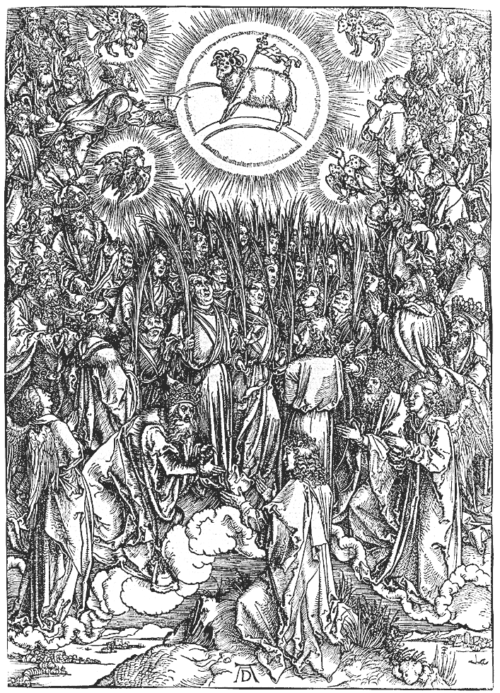

Spiritual Communion

The BCP teach (in the Ministration to the Sick) that if one is prevented from receiving even both the physical elements of the Sacrament, one is not prevented from receiving what God offers us in Communion:

“If a person desires to receive the Sacrament, but, by reason of extreme sickness or physical disability, is unable to eat and drink the Bread and Wine, the Celebrant is to assure that person that all the benefits of Communion are received, even though the Sacrament is not received with the mouth.” (BCP 457)

The following prayers can be said, either at home, or at church, if one is unable to receive both of the elements of the Sacraments.

Remember also the Church’s teaching in the doctrine of concomitance. This teaching is that the whole Christ is present in every particle of both the bread and wine. Otherwise, it would mean that if one receives more bread or wine (or more of both, as the priest usually does) one would receive more of the Lord, which is clearly absurd (and impossible!). This is an important fact to keep in mind when illness of any sort (whether short or long-term) keeps us from receiving one of the Elements. Regardless of whether we receive a large or small amount, in one kind or in both, or even without the elements, but only by desire—one always receives the fullness of the Sacrament.

I

O my most loving Saviour, since I cannot have the happiness of receiving thee this day, suffer me to gather up the crumbs under thy table, and to unite myself to thy divine Heart by faith, hope and charity.

I confess that I do not deserve the children’s bread, but I venture humbly to declare that away from thee my soul is dried up for thirst, and my heart cast down with faintness.

Come, then unto me, O my divine Jesus, come into my mind to illuminate it with thy light; come into my heart to enkindle in it the fire of thy love, and to unite it so ultimately with thine own that it may be no more I that live but thou that livest in me, and reignest in me for ever. Amen.

II

O eternal Father, look here upon thy beloved Son in whom thou art well pleased, and turn away thy face from my sins; for he bare our sins in his own body on the tree, and with his stripes we are healed.

With the publican would I smite my breast in deepest sorrow for those sins which drew down on him such heavy punishment. For his sake be merciful to me a sinner. Amen.

Lord Jesus Christ, son of the living God, who by thy death hast given life unto the world, deliver me from all my sins, and keep me from evil. Make me to abide always in thy commandments, and never suffer me to be separated from thee, who with the Father and the Holy Ghost livest and reignest one God, world without end. Amen.

Hear me, O Lord Jesu, who sittest on high with the Father, and art here invisibly present with us, and since I cannot now receive thee sacramentally, enter spiritually into my soul, cleanse it from its sins and imperfections . . . adorn it with heavenly gifts and graces . . . and make me worthy with all thy people to partake of thy spotless Body and precious Blood. Amen.

III

O my sweet Saviour, Jesus Christ, thou art my Sovereign Good, the Fountain of all good, my God and my all. I most firmly believe that for us sinners and for our salvation thou was pleased to come down from heaven, to take upon thee, by the mystery of thine Incarnation, our human nature, and to become one of us, that so thou mightest be our High Priest and our Victim. I most firmly believe that thou offeredst thyself upon the cross a sacrifice for us all, after having suffered many cruel torments; and that, by thy glorious resurrection and ascension, thou hast opened the gates of heaven for us. I most firmly believe that in these sacred mysteries thou are truly are really present, and that thy sacred Body and Blood are here presented in sacrifice, and verily and indeed received by the faithful in remembrance of thy death.

O how happy are those souls who worthily receive thee in this divine sacrament. O what grace, what sanctity, do they receive from this fountain of all sanctity. O merciful Saviour, have compassion on me, and suffer me at least to sigh after thee, and, though I am unworthy of thine embraces, permit me, like the penitent Magdalene, to present myself at least before thy feet, and wash them in spirit with my tears. O may thy sacred Blood, which thou hast shed for all sinners, cleanse my sinful soul this day from all its guilt.

O come to me, dear Lord, in spirit, and take possession of all the powers of my soul. Enlighten mine understanding, and inflame my will with thy love. O let me be thine and be thou mine from henceforth and for ever; and grant that nothing, in life or death, may ever separate me from thee any more. In this one prayer hear me, O Lord, and in all things else do with me as thou wilt. Amen.

IV

In union, O dear Lord, with the faithful at every altar of thy Church [especially at . . .] where thy death and passion are pleaded before the Father, I desire to offer thee praise and thanksgiving; I present unto thee my soul and body with the earnest wish that I may be ever united to thee. And since I cannot now receive thee sacramentally, I beseech thee to come spiritually into my heart. I unite myself to thee with all the affections of my soul. O let nothing ever separate me from thee, let me live and die in thy love. Amen.

God our Father, whose Son our Lord Jesus Christ in a wonderful Sacrament hath left unto us a memorial of his passion: Grant us so to venerate the sacred mysteries of his Body and Blood, that we may ever perceive within ourselves the fruit of his redemption; who liveth and reigneth with thee and the Holy Spirit, one God, for ever and ever. Amen. (BCP, p. 201).

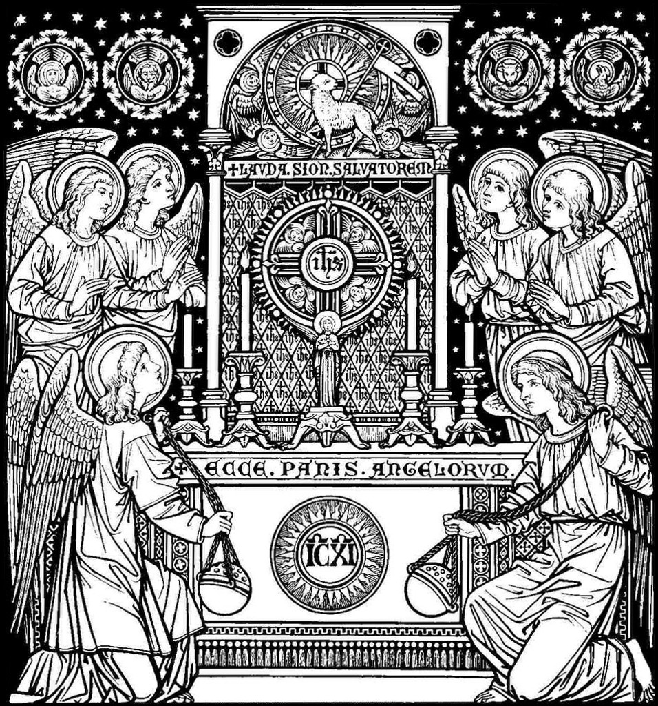

The Prayer for Nashotah House

Bless, O Lord, this House,
set apart to the glory of thy great name
and the benefit of thy Holy Church;
and grant that thy Name may be worshipped here
in truth and purity to all generations.
Give thy grace and wisdom to all the authorities,
that they may exercise holy discipline,
and be themselves patterns of holiness, simplicity, and self-denial.

Bless all who may be trained here;
take from them all pride, vanity, and self-conceit,
and give them true humility and self-abasement.
Enlighten their minds, subdue their wills, purify their hearts,
and so penetrate them with thy Spirit and fill them with thy love,
that they may go forth animated with earnest zeal for thy glory;
and may thine ever-living Word so dwell within their hearts,
that they may speak with that resistless energy of love
which shall melt the hearts of sinners to the love of thee.

Open, O Lord, the hearts and hands of thy people,
that they may be ready to give and glad to distribute to our necessities.
Bless the founders and benefactors of this House,
and recompense them with the riches of thy everlasting kingdom,
for Jesus' sake. Amen.

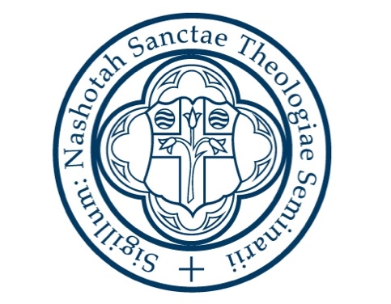

Nashotah House
Theological Seminary

