The Daily Office
during the
Sacred Triduum

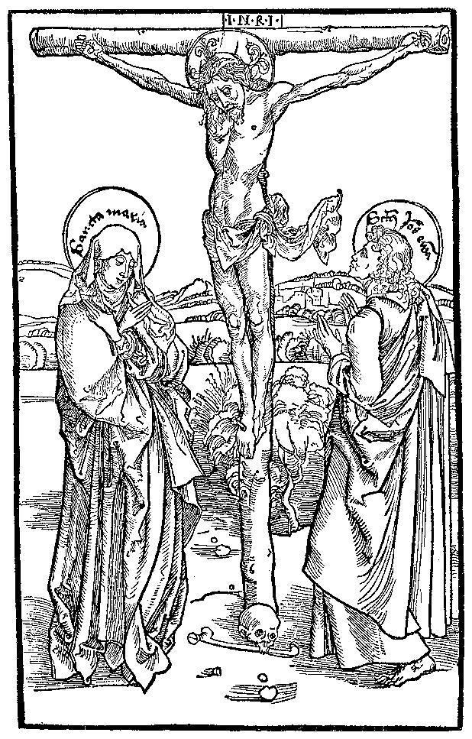

Nashotah House

Theological Seminary

Historically, particularly in monastic and collegiate settings, the following (which are all later additions) are all omitted on these three Holy Days: The Preces; The Invitatory (Venite); The Gloria Patri on all Psalms and Canticles; Proper Office Hymns and their Antiphons; The Salutation (“The Lord be with you”) and “Let us Pray”; The Closing Versicles.
Because the Offices are shorter, and also because the Psalter is the anchor of the Office, additional psalms have been added to some of the days.

Morning Prayer

Standing, the Officiant silently says,
O Lord, open thou our lips; and our mouth shall show forth thy praise.

Then all sit and the Office begins without introduction, beginning directly with the appointed Antiphon and Psalm.

Psalter
The Gloria Patri is not said from now until Easter. The following antiphon will be said at the beginning and end of all the psalms assigned for each day:
The Lord was led as a lamb to the slaughter,
and he opened not his mouth.

Maundy Thursday: Psalms 56 (BCP 662); 64 (BCP 671); 102 (BCP 731)
Good Friday: Psalms 22 (BCP 610); 40 (BCP 640); 54 (BCP 659)
Holy Saturday: Psalms 23 (BCP 612); 30 (BCP 621); 88 (BCP 712)

The First Lesson

A Song of Penitence Kyrie Pantokrator
Prayer of Manasseh, 1-2, 4, 6-7, 11-15

O Lord and Ruler of the hosts of heaven, *
God of Abraham, Isaac, and Jacob, and of all their righteous offspring:
Thou madest the heavens and the earth, *
with all their vast array.
All things quake with fear at thy presence; *
they tremble because of thy power.
But thy merciful promise is beyond all measure; *
it surpasses all that our minds can fathom.
O Lord, thou art full of compassion, *
long-suffering, and abounding in mercy.
Thou holdest back thine hand; *
Thou dost not punish as we deserve.
In thy great goodness, Lord, Thou hast promised forgiveness to sinners, *
that they may repent of their sin and be saved.
And now, O Lord, I bend the knee of my heart, *
and make my appeal, sure of thy gracious goodness.
I have sinned, O Lord, I have sinned, *
and I know my wickedness only too well.
Therefore I make this prayer to thee: *
Forgive me, Lord, forgive me.
Do not let me perish in my sin, *
nor condemn me to the depths of the earth.
For thou, O Lord, art the God of those who repent, *
and in me thou wilt show forth thy goodness.
Unworthy as I am, thou wilt save me, in accordance with your great mercy, *
and I will praise thee without ceasing all the days of my life.
For all the powers of heaven sing thy praises, *
and thine is the glory to ages of ages. Amen.

The Second Lesson

Benedictus – Song of Zechariah

Antiphon
Christ for us became obedient unto death.
On Good Friday, add, even death on the cross.
On Holy Saturday, also add, wherefore God also hath highly exalted Him, and given Him a Name which is above every Name.

Blessed be the Lord God of Israel, *
for he hath visited and redeemed his people;
And hath raised up a mighty salvation for us *
in the house of his servant David,
As he spake by the mouth of his holy prophets, *
which have been since the world began:
That we should be saved from our enemies, *
and from the hand of all that hate us;
To perform the mercy promised to our forefathers, *
and to remember his holy covenant;
To perform the oath which he sware to our forefather Abraham,*
that he would give us,
That we being delivered out of the hand of our enemies *
might serve him without fear,
In holiness and righteousness before him, *
all the days of our life.

And thou, child, shalt be called the prophet of the Highest, *
for thou shalt go before the face of the Lord to prepare his ways;
To give knowledge of salvation unto his people *
for the remission of their sins,
Through the tender mercy of our God, *
whereby the dayspring from on high
hath visited us;
To give light to them that sit in darkness and in the shadow of death, *
and to guide our feet into the way of peace.

The Glory be is omitted, but the antiphon is repeated.

All kneel and the Our Father is then said is silence.

Psalm 51 Miserere mei, Deus (said in unison in a low voice)
1. HAVE mercy upon me, O God, after thy great goodness*
according to the multitude of thy mercies do away mine offences.
2. Wash me throughly from my wickedness*
and cleanse me from my sin.
3. For I acknowledge my faults*
and my sin is ever before me.
4. Against thee only have I sinned, and done this evil in thy sight*
that thou mightest be justified in thy saying,
and clear when thou art judged.
5. Behold, I was shapen in wickedness*
and in sin hath my mother conceived me.
6. But lo, thou requirest truth in the inward parts*
and shalt make me to understand wisdom secretly.
7. Thou shalt purge me with hyssop, and I shall be clean*
thou shalt wash me, and I shall be whiter than snow.
8. Thou shalt make me hear of joy and gladness*
that the bones which thou hast broken may rejoice.
9. Turn thy face from my sins*
and put out all my misdeeds.
10. Make me a clean heart, O God*
and renew a right spirit within me.
11. Cast me not away from thy presence*
and take not thy holy Spirit from me.
12. O give me the comfort of thy help again *
and stablish me with thy free Spirit.
13. Then shall I teach thy ways unto the wicked*
and sinners shall be converted unto thee.

14. Deliver me from blood-guiltiness, O God,
thou that art the God of my health*
and my tongue shall sing of thy righteousness.
15. Thou shalt open my lips, O Lord*
and my mouth shall shew thy praise.
16. For thou desirest no sacrifice, else would I give it thee*
but thou delightest not in burnt-offerings.
17. The sacrifice of God is a troubled spirit*
a broken and contrite heart, O God, shalt thou not despise.
18. O be favourable and gracious unto Sion*
build thou the walls of Jerusalem.
19. Then shalt thou be pleased with the sacrifice of righteousness,
with the burnt-offerings and oblations*
then shall they offer young bullocks upon thine altar.

The Officiant then says
Almighty God, we beseech thee graciously to behold this thy family, for which our Lord Jesus Christ was contented to be betrayed, and given up into the hands of wicked men, and to suffer death upon the cross;
The conclusion is said silently.
who now liveth and reigneth with thee and the Holy Ghost ever, one God, world without end. Amen

In place of the above, the following is used instead on Holy Saturday
Grant, O Lord, that as we are baptized into the death of thy blessed Son our Saviour Jesus Christ, so by continual mortifying our corrupt affections we may be buried with him; and that, through the grave, and gate of death, we may pass to our joyful resurrection; for his merits, who died, and was buried, and rose again for us, thy Son Jesus Christ our Lord,
The conclusion is said silently.
who liveth and reigneth, world without end. Amen.

Evening Prayer

Standing, the Officiant silently says,
O Lord, open thou our lips; and our mouth shall show forth thy praise.

Then all sit and the Office begins without introduction, beginning directly with the appointed Antiphon and Psalm.

Psalter
The Gloria Patri is not said from now until Easter. The following antiphon will be said at the beginning and end of all the psalms assigned for each day:
Thou hast comforted us, O Lord, in thy strength,
And refreshed us in thine holiness.

Maundy Thursday: Psalms 142, 143 (BCP 798)
Good Friday: Psalms 69 (BCP 679); 88 (BCP 712)
Holy Saturday: Psalm 27 (BCP 617)

The First Lesson

Magnificat - The Song of Mary (standing)

Antiphon
Christ for us became obedient unto death.
On Good Friday, add, even death on the cross.
On Holy Saturday, also add, wherefore God also hath highly exalted Him, and given Him a Name which is above every Name.

My soul doth magnify the Lord, *
and my spirit hath rejoiced in God my Savior.
For he hath regarded *
the lowliness of his handmaiden.
For behold from henceforth *
all generations shall call me blessed.
For he that is mighty hath magnified me, *
and holy is his Name.
And his mercy is on them that fear him *
throughout all generations.
He hath showed strength with his arm; *
he hath scattered the proud
in the imagination of their hearts.
He hath put down the mighty from their seat, *
and hath exalted the humble and meek.
He hath filled the hungry with good things, *
and the rich he hath sent empty away.
He remembering his mercy hath
holpen his servant Israel, *
as he promised to our forefathers,
Abraham and his seed for ever.

The Glory be is omitted but the antiphon is repeated

The Second Lesson

Nunc dimittis – The Song of Simeon (standing)

Lord, now lettest thou thy servant depart in peace, *
according to thy word;
For mine eyes have seen thy salvation, *
which thou hast prepared before the face of all people,
To be a light to lighten the Gentiles, *
and to be the glory of thy people Israel.

All kneel.

The Office concludes as at Morning Prayer; see page 5 of this booklet.

